4 May, 2026

PRESS RELEASE

TOURISM STATISTICS 2025

Travelers

The movement of travelers to and from Cyprus in 2025 recorded an increase compared to 2024. Total arrivals of travelers reached 7.102.208 recording an increase of 13,0% and departures totaled 7.076.521, also recording an increase of 12,8% compared to 2024 (Figure 1).

Air traffic accounted for 96,8% of both arrivals and departures in 2025.

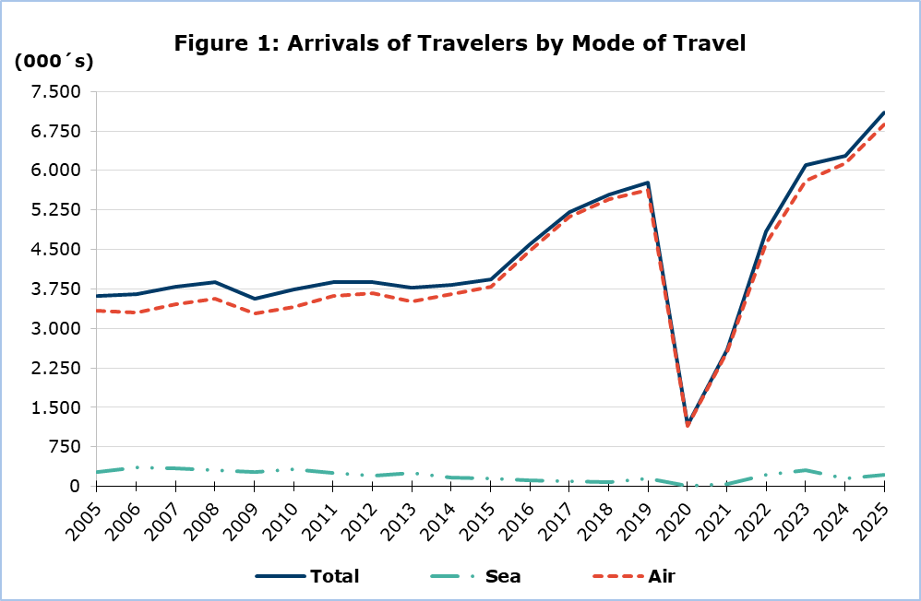

Tourists

Tourist arrivals increased by 12,2% and reached 4.534.073 in 2025 compared to 4.040.200 in 2024 (Figure 2).

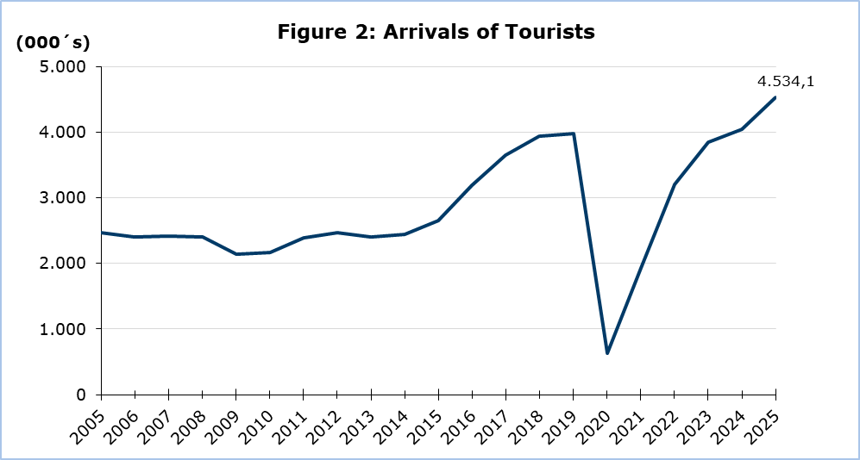

During 2025, the United Kingdom was the most important source of tourism for Cyprus with a share of 31,8% of the total tourist traffic, followed by Israel with 13,0%, Poland with 8,2%, Germany with 6,1%, Greece with 3,9% and Sweden with 3,4% (Figure 3).

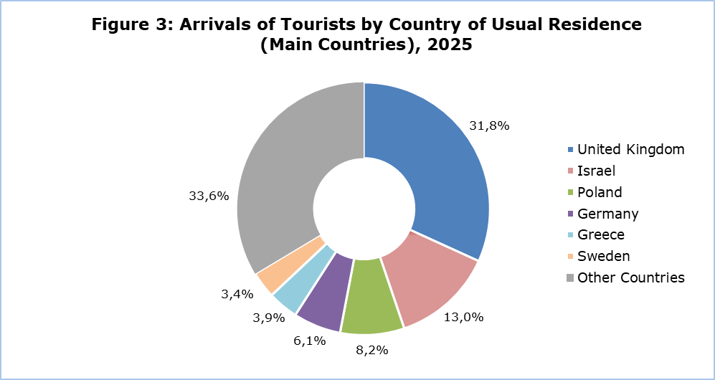

For a percentage of 79,8% of tourists, the purpose of their trip in 2025 was holidays, for 13,1% visit to friends and relatives and for 7,0% business.

Revenue from Tourism

In 2025, revenue from tourism was estimated at €3.696,1 mn, compared to €3.209,4 mn in 2024, recording an increase of 15,2%.

The average expenditure per person was €815,16 in 2025, recording an increase of 2,6% from 2024. The highest average expenditure per person in 2025 was recorded in the month of August with €966,41 and the lowest in the month of February with €595,71 (Figure 4).

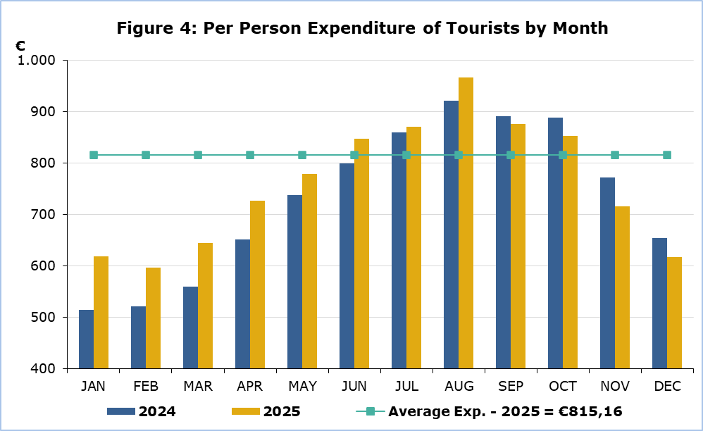

Residents of Cyprus

The trips of residents of Cyprus abroad increased by 11,9% in 2025, and reached 1.963.593 as compared to 1.754.937 in 2024.

In 2025 32,6% visited Greece, 8,9% the United Kingdom, 5,5% Italy, 3,8% Russia, 3,5% Germany and 3,3% Poland. The highest number of trips for residents was recorded in August, while the lowest number of trips in February.

A percentage of 73,1% of the residents of Cyprus traveling abroad in 2025 stated that the main reason for traveling was holidays, 20,5% stated professional reasons, 5,3% studies and 1,1% other purposes.

METHODOLOGICAL NOTES

Definitions

Travelers - Are all persons who pass through passport control at the ports and airports of Cyprus. The various categories of travelers are visitors, residents, emigrants and immigrants.

Tourists - Are visitors staying at least one night in Cyprus.

Revenue from Tourism - It refers to the revenue from tourists during their visit to Cyprus.

Residents of Cyprus - This category includes persons who have resided in Cyprus for at least 12 months prior to their travel.

Source of Data and Coverage

The data are obtained from the Passengers Survey which is carried out at the points of arrival in Larnaka and Pafos airports. Additionally, data are also collected from administrative sources, such as the monthly arrivals from ports.

The data cover all persons who pass through passport control at the ports and airports in the Government controlled area of Cyprus. It does not include travelers who arrive and depart illegally via ports and airports in the occupied part of Cyprus.

The grossing - up is conducted based on the data sent to the Statistical Service by the Civil Aviation Department and from the cruise passenger lists, as well as on the data sent by other administrative sources.

During the period of June 2020 – April 2022, the Passengers Survey at Arrivals was temporarily discontinued and the data were obtained from the electronic platform “Cyprus Flight Pass”.

For more information:
CYSTAT Portal, subtheme Tourism
CYSTAT-DB (Online Database)
Publications
Methodological Information

Contact
Lucy Panayidou: Tel.: +35722602152, E-mail: lpanagidou@cystat.mof.gov.cy

